School Based Inquiry and Data Driven Instruction Teams
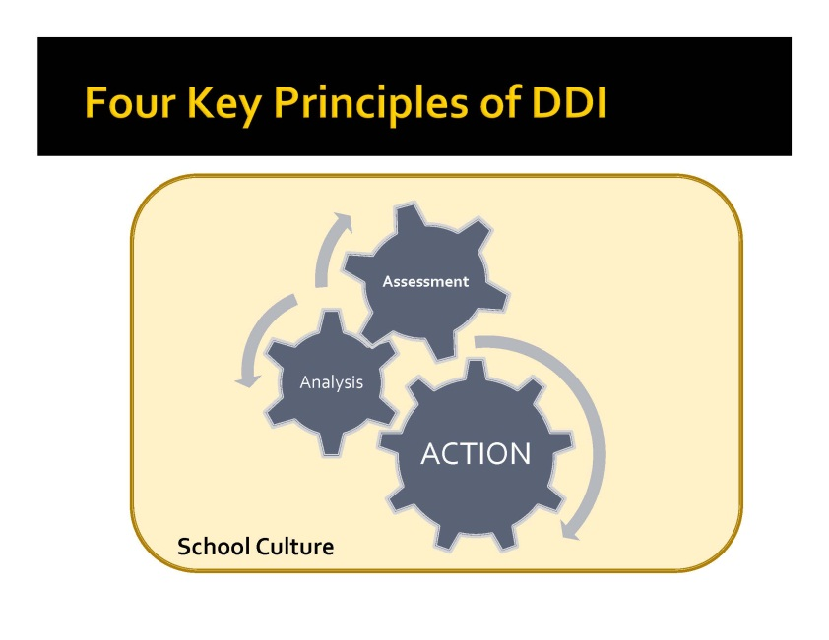
2011-2012

- Assess school’s current implementation of data driven instruction
  - Where do you have “pockets” of inquiry?
  - How are you currently using data?
- Develop an implementation plan for data driven instruction, tailored to the specific needs and goals of the district/building
  - What are the areas of focus for your district/building?
  - Where can you build capacity?
- Support development of data driven culture in teams of teachers and school leadership teams
  - What role will administrators play? Teacher leaders?
  - What professional development/support is needed?
- Link instruction and follow-up analysis and action planning
- Align instructional practices, assessments and analysis to the rigor of the Common Core Learning Standards
- Support/lead analysis meetings with teacher teams that increase student learning
- Build/identify high-quality assessment tools for classroom use

